<html>

<head>

<link rel="style sheet" type="css" href="A.css">

</head>

<title> GALLERY </title>

<body background="C:\Users\HP\Desktop\bg.png"><br><br><br><br>

<div id="grade">

<h1 align="center"> PHOTO GALLERY </h1><br><br>

<h2 align="center">

<a href="cars.html">CARS</a><br><br>

<a href="animals.html">ANIMALS</a><br><br>

<a href="plants.html">PLANTS</a><br><br>

</h2>

</div>

</body>

</html>

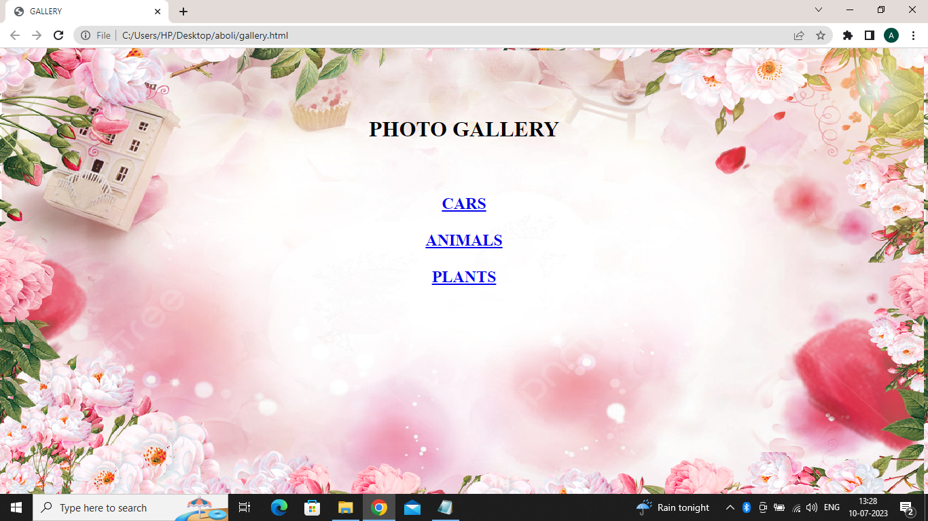

**html>**

**<head>**

**<title> CARS </title>**

**<link rel="stylesheet" href="A.css">**

**</head>**

**<body>**

**<h1 align="center">CARS<h1>**

**<img src="C:\Users\HP\Desktop\cars.png"**

**</body>**

**</html>**



<html>

<head>

<title> ANIMALS </title>

<link rel="stylesheet" href="A.css">

</head>

<body>

<h1>ANIMALS<h1>

<img src="C:\Users\HP\Desktop\animals.png">

</body>

</html>

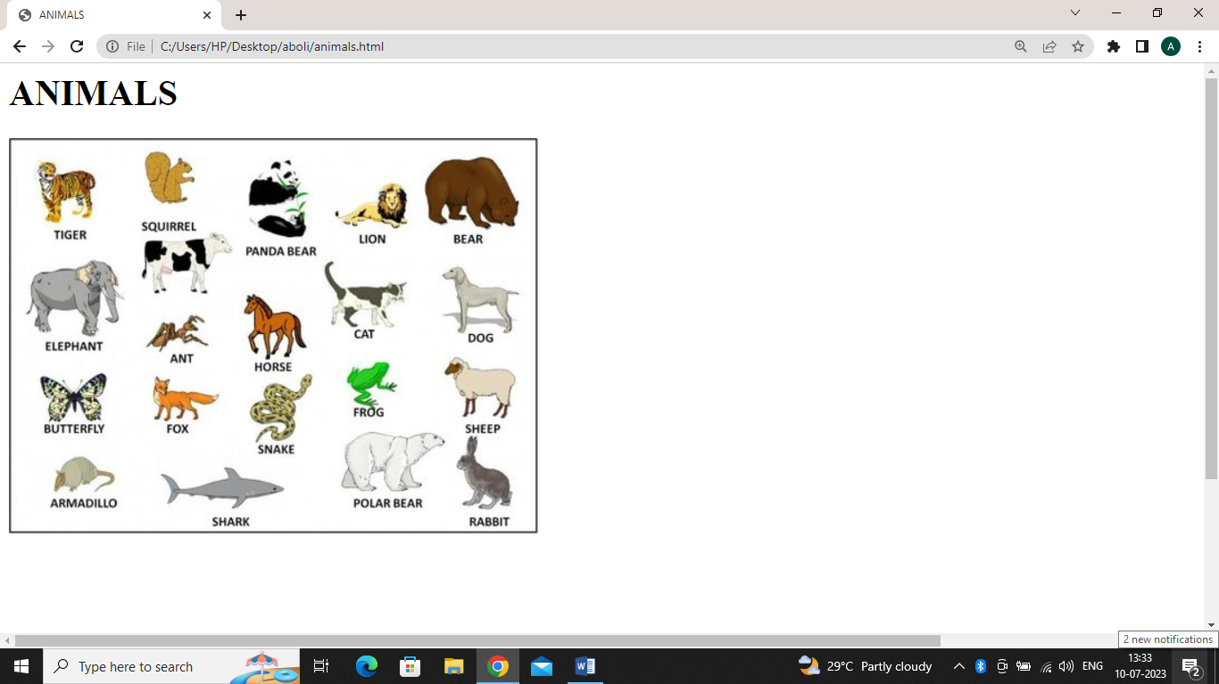

**<html>**

**<head>**

**<title> PLANTS </title>**

**<link rel="stylesheet" href="A.css">**

**</head>**

**<body>**

**<h1>PLANTS</h1>**

**<img src="C:\Users\HP\Desktop\plants.png"**

**</body>**

**</html>**

